Home Work #2

Saad Ahmad

20P-0051

1. Run nslookup to obtain the IP address of a Web server in Asia. What is the IP address of that server?

I queried the webpage for the Asian Institute of Technology in Thailand. The IP address of that server was 203.159.12.3.

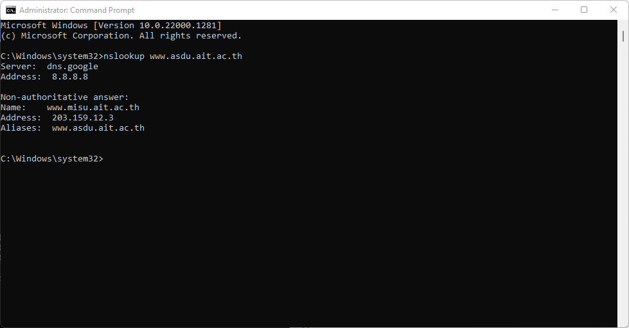

2. Run nslookup to determine the authoritative DNS servers for a university in Europe.

Using webpage for Cambridge University in England.

Webpage: [**http://www.cam.ac.uk**](http://www.cam.ac.uk/).

The authoritative DNS server is: primary.dns.cam.ac.uk

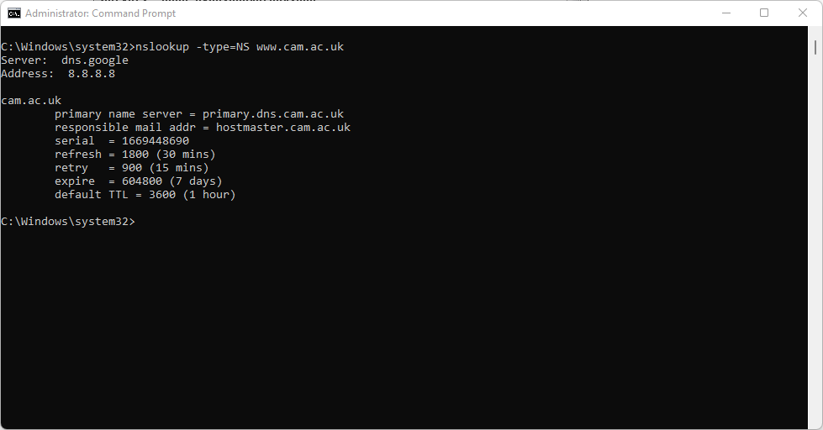

3. Run nslookup so that one of the DNS servers obtained in Question 2 is queried for the mail servers for Yahoo! mail. What is its IP address?

The IP address for the DNS server if queried for the Yahoo! mail server is 87.248.119.251

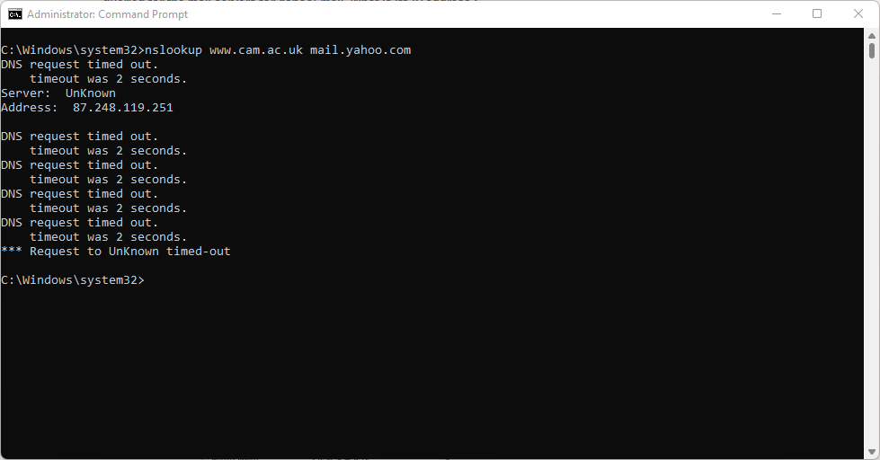

Task #2

1. Locate the DNS query and response messages. Are then sent over UDP or TCP?

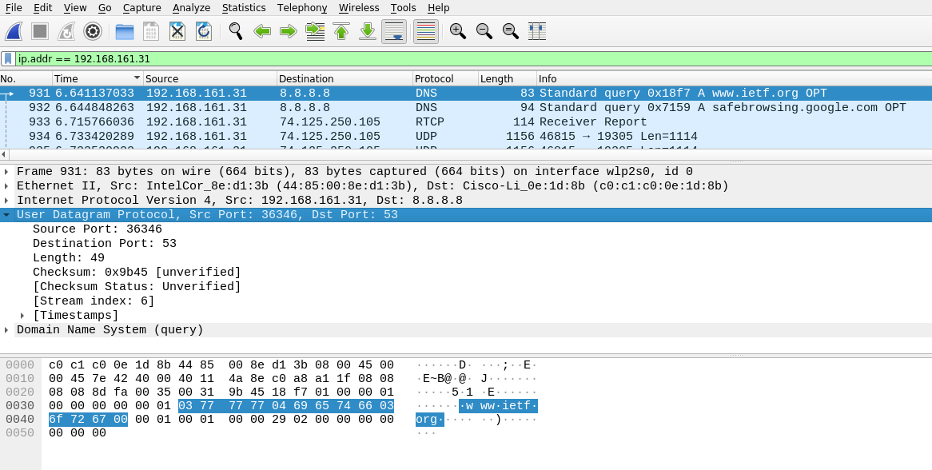

The DNS query and response messages are sent over UDP.

2. What is the destination port for the DNS query message? What is the source port of DNS response message?

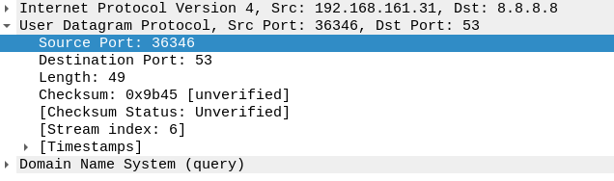

Source Port: 36346

Destination Port: 53

3. To what IP address is the DNS query message sent? Use ipconfig to determine the IP address of your local DNS server. Are these two IP addresses the same?

The DNS query was sent to IP address 8.8.8.8. Yes it is the same IP address as that of my local DNS server.

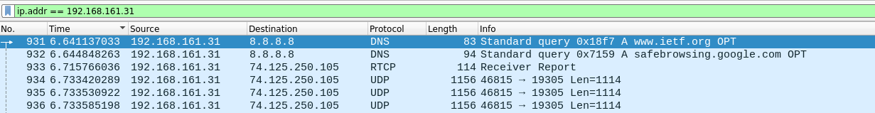

My local DNS server:

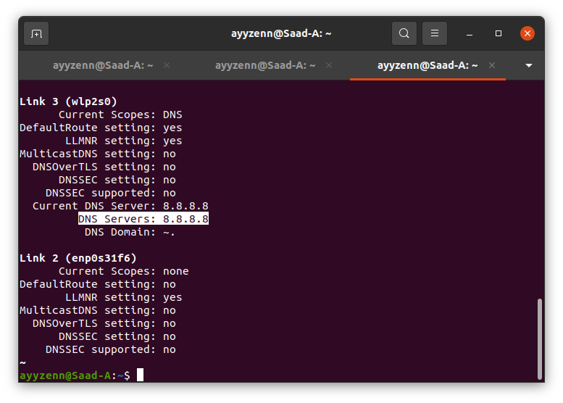

4. Examine the DNS query message. What “Type” of DNS query is it? Does the query message contain any “answers”?

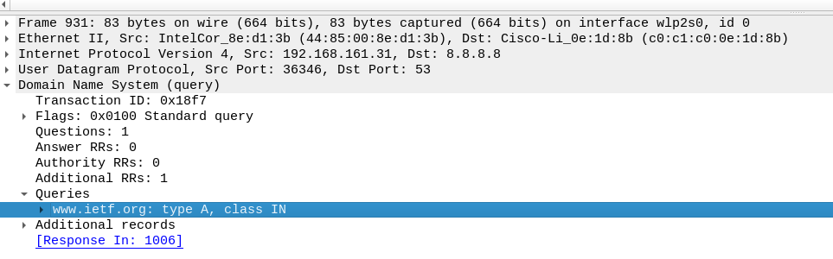

The query message was a type “A” query, but the message did not contain any “answers.”

5. Examine the DNS response message. How many “answers” are provided? What do each of these answers contain?

There are 3 answers and these answers contains Name, Type, Class, TTL, Data Length and address

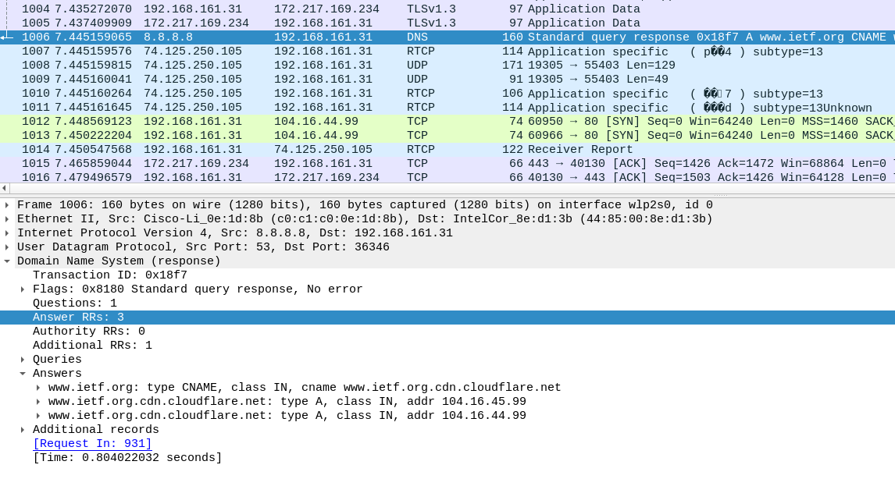

6. Consider the subsequent TCP SYN packet sent by your host. Does the destination IP address of the SYN packet correspond to any of the IP addresses provided in the DNS response message?

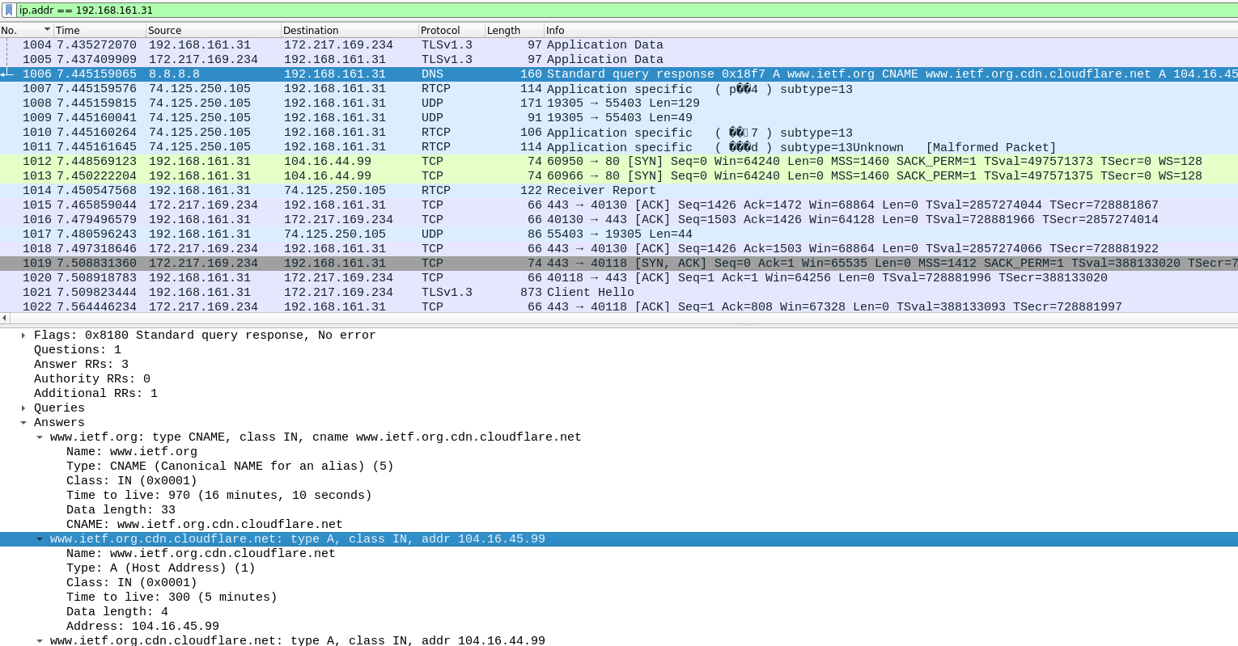

Destination IP: 104.16.45.99. Yes, this IP was in DNS response

7. This web page contains images. Before retrieving each image, does your host issue new DNS queries?